1. Create Customers and Order tables DDL statements

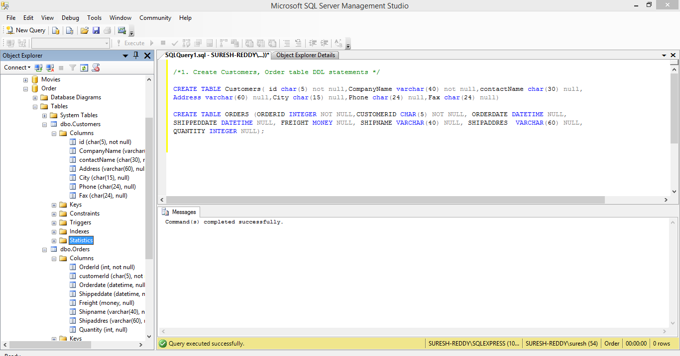

1. Alter Orders table statement

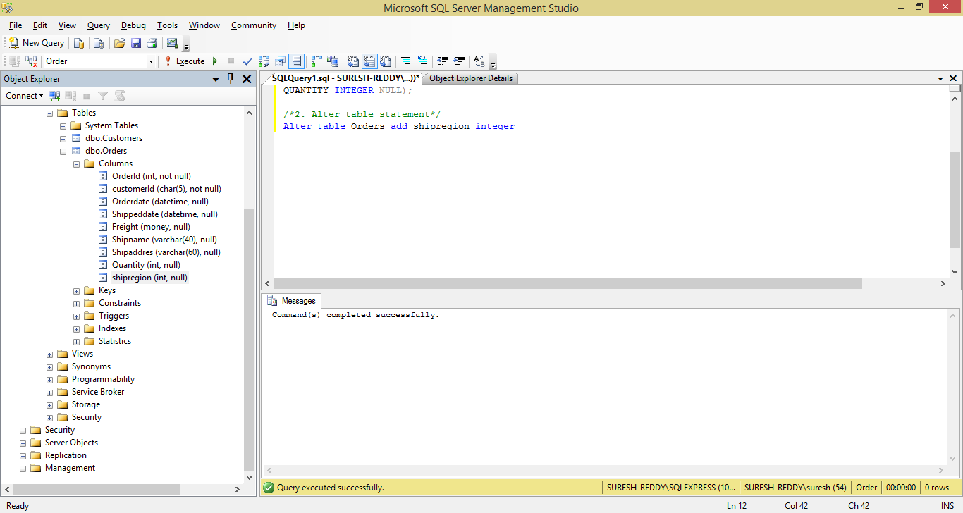

3. Alter table to modify data type

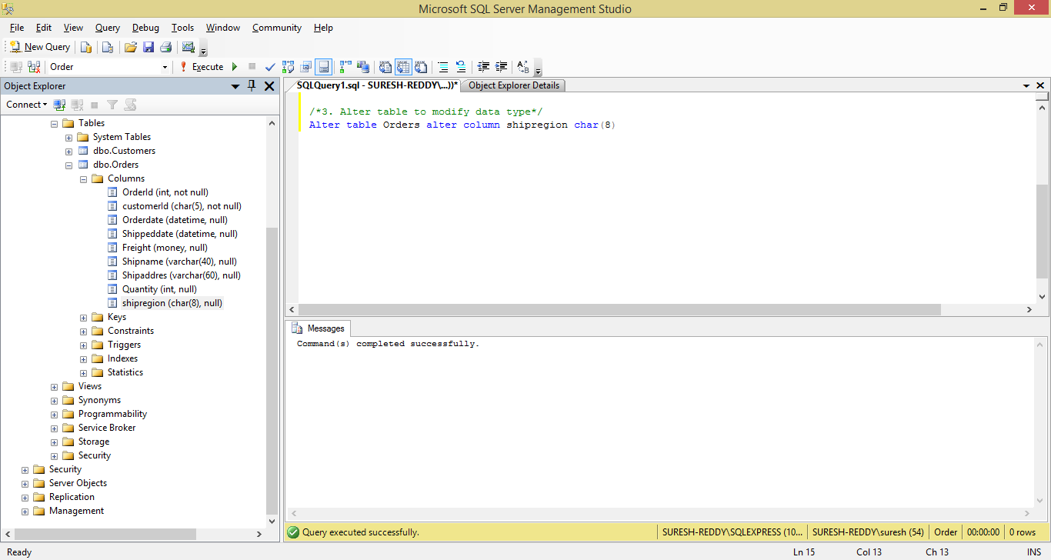

4. Alter table to drop column

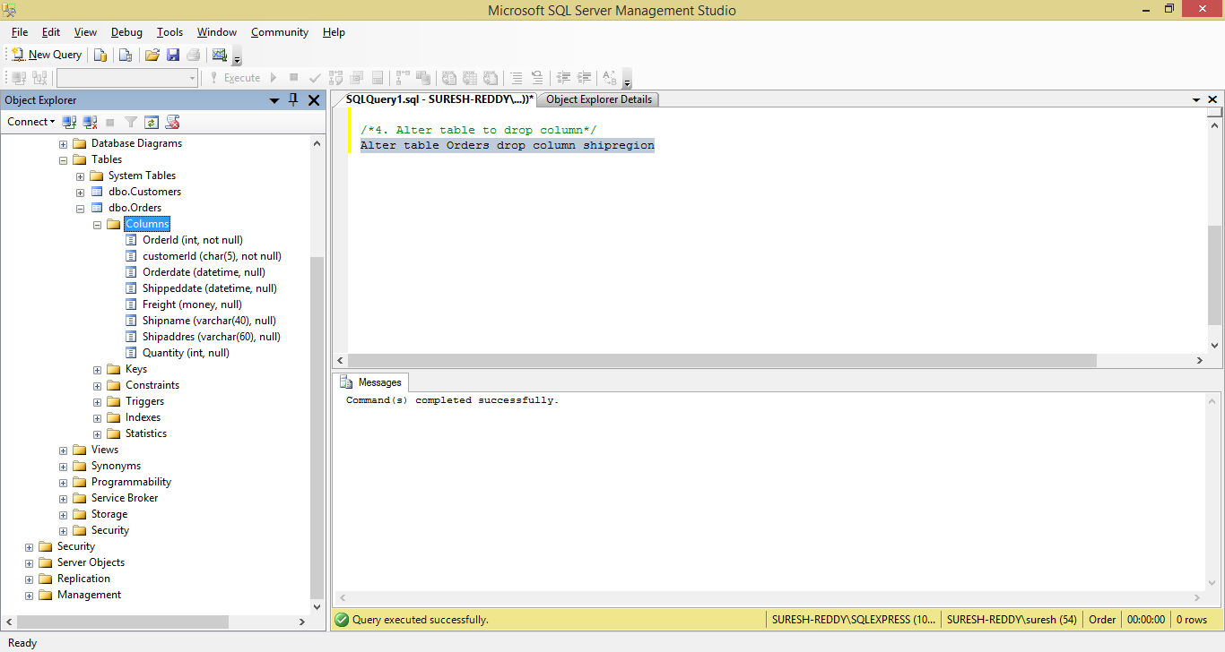

5. Alter statement to add default value

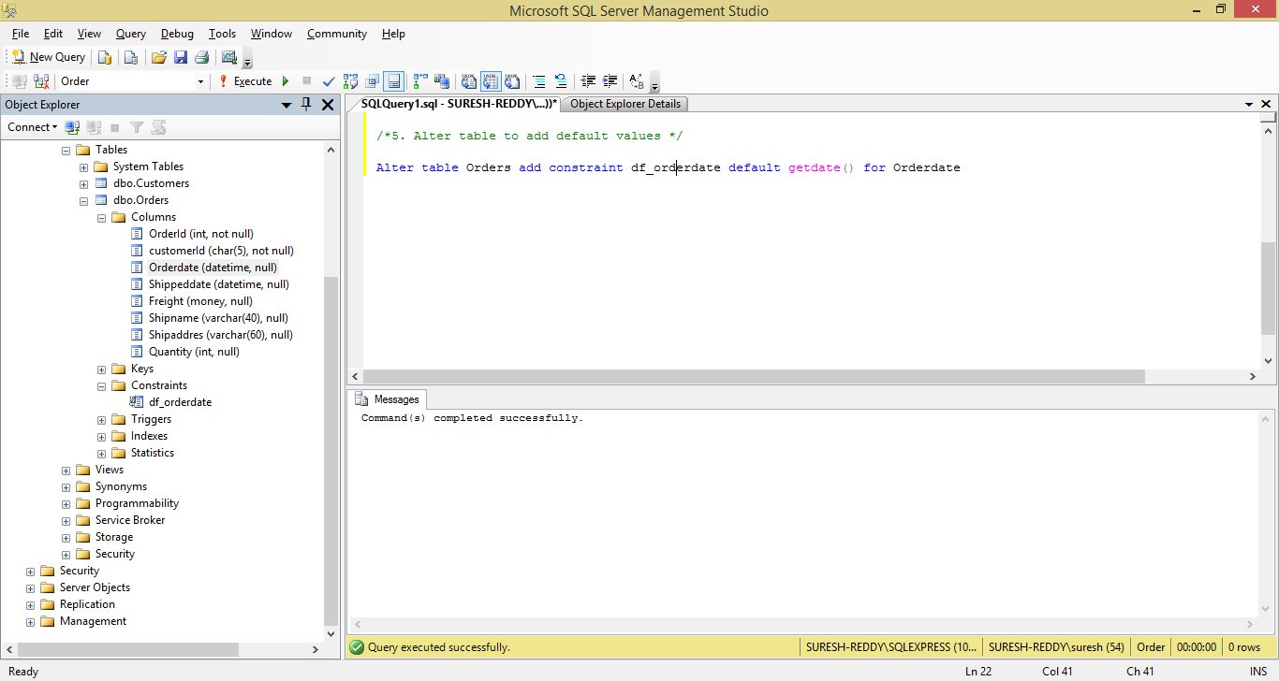

6. Rename the column of Customers table

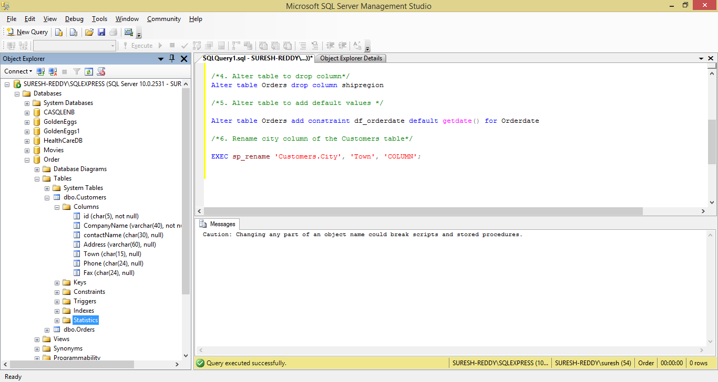

7. Create department and insert values

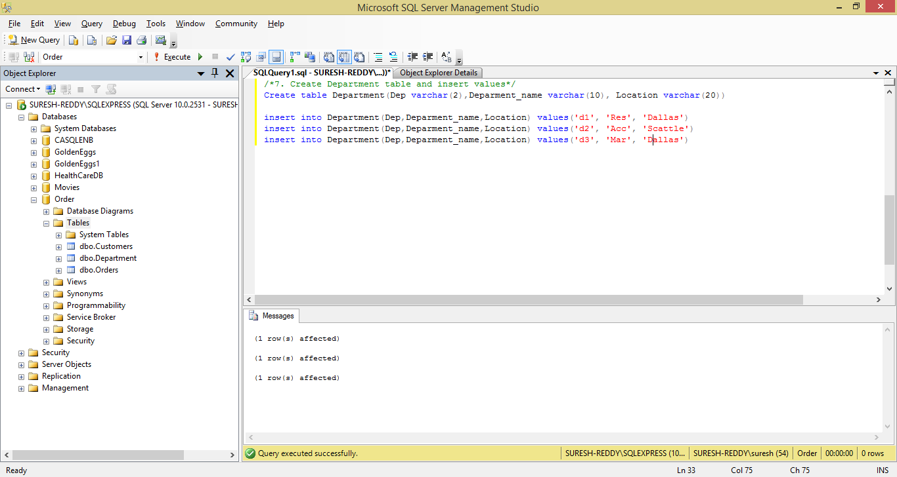

Create Employee table and Insert table

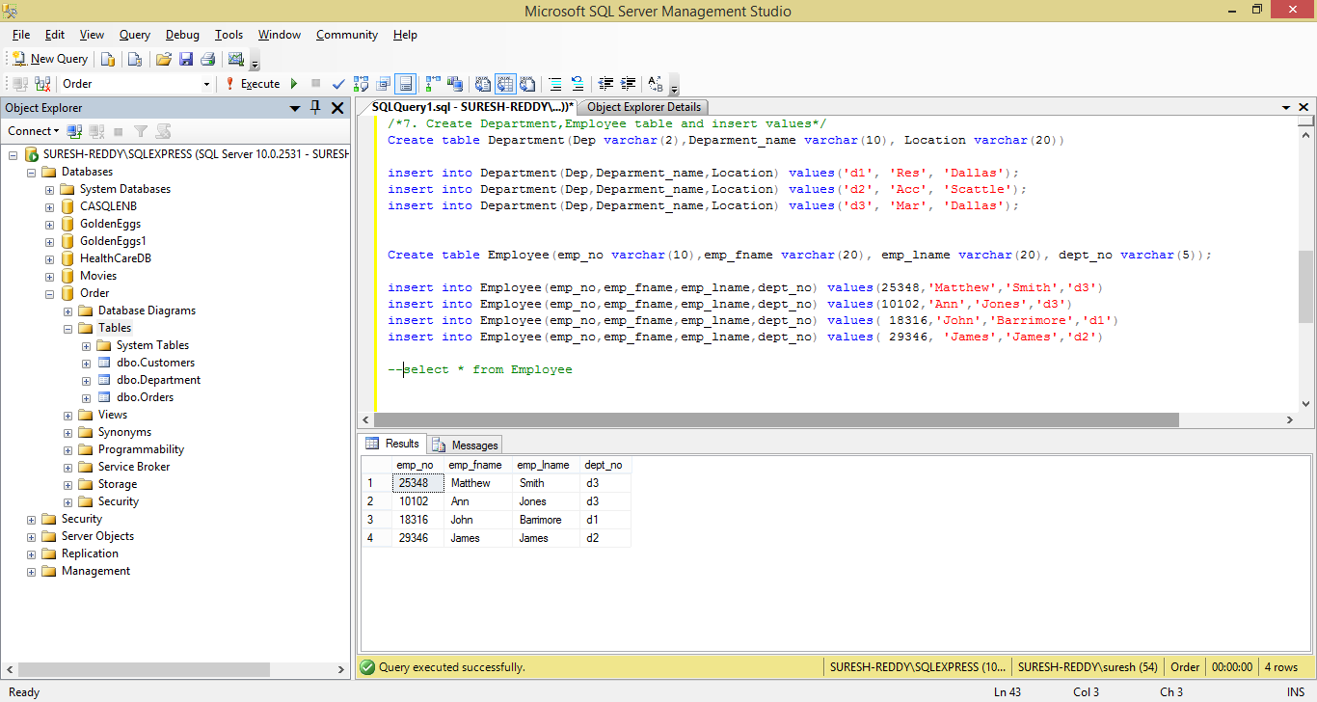

Create Project Table and Insert values

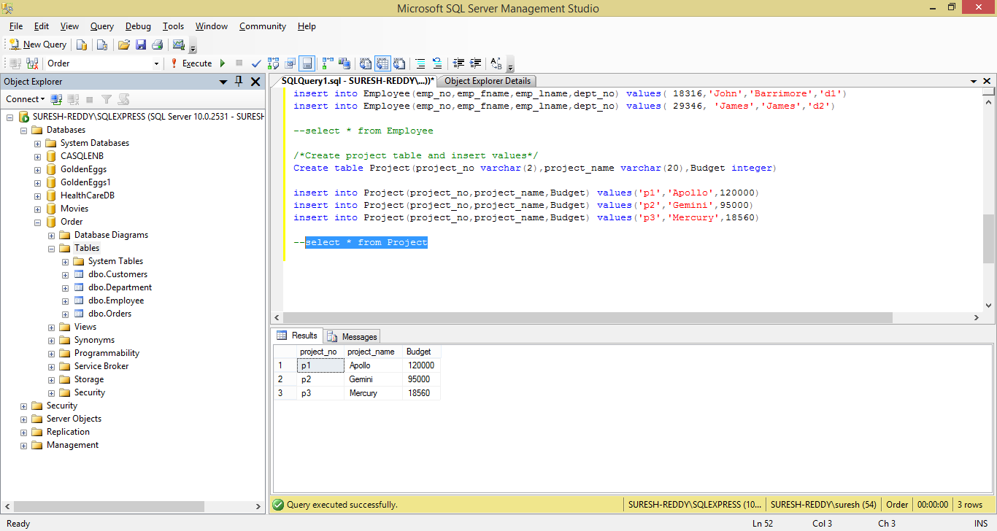

Create Works_on table and insert table

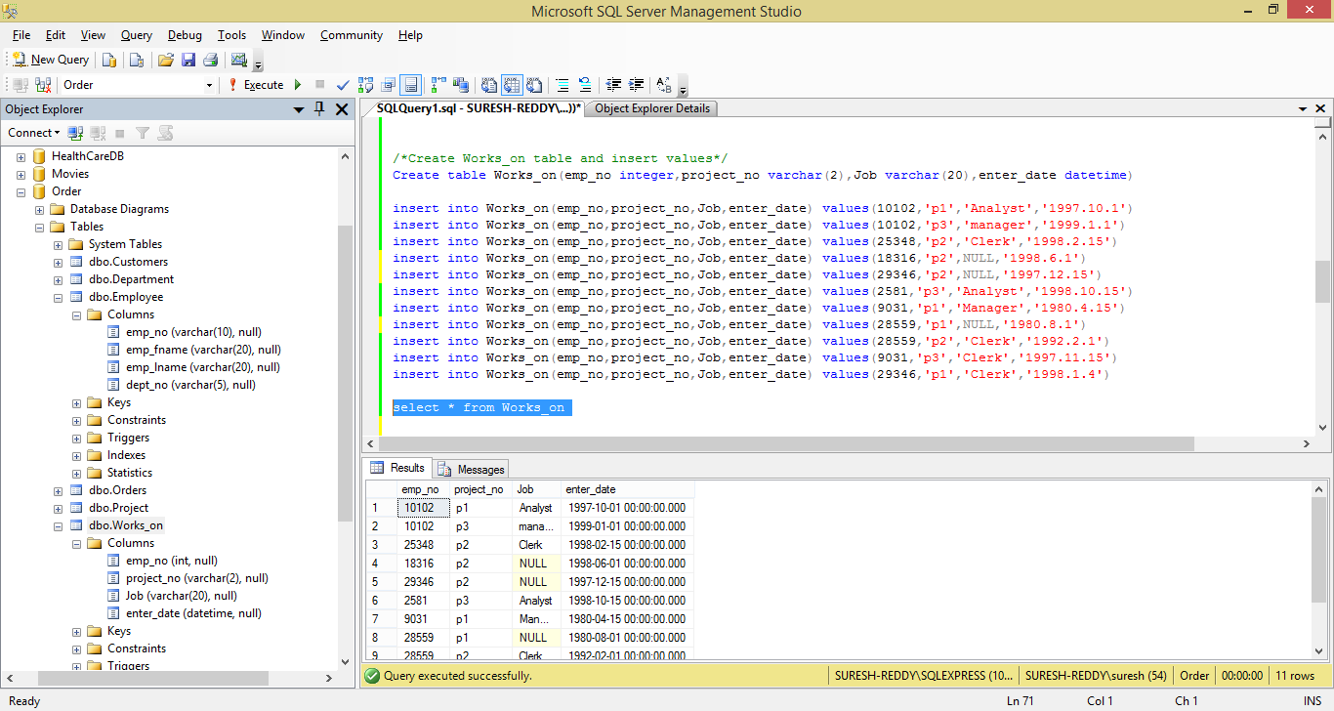

Simple Queries:-

1. Get the employee numbers for employees working in project p2, and having employee numbers smaller than 10000. Solve this problem with two different but equivalent SELECT statements

SELECT EMP.* FROM

EMPLOYEE EMP INNER JOIN WORKS_ON WORKS

ON EMP.EMP_NO=WORKS.EMP_NO

WHERE PROJECT_NO='P2';

/*No Results from this query*/

SELECT * FROM EMPLOYEE

WHERE EMP_NO<10000;

SELECT * FROM WORKS_ON

WHERE EMP_NO<10000;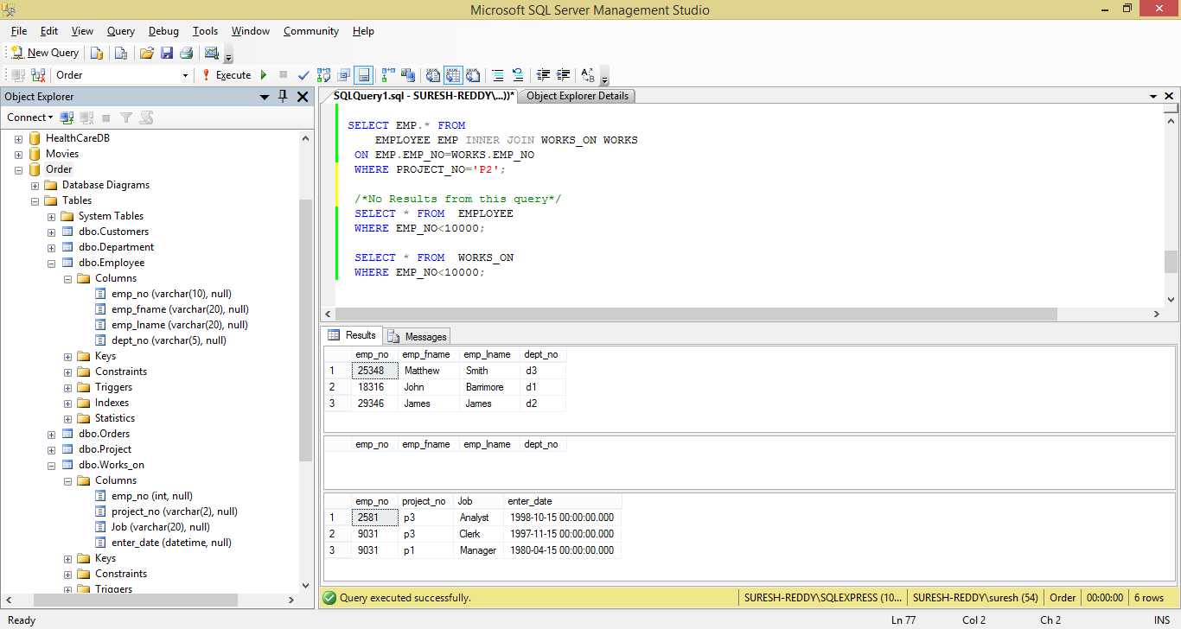

1. Get the employee numbers for all employees who didn’t enter their project in 1998

SELECT DISTINCT EMP_NO FROM WORKS_ON WHERE YEAR(ENTER_DATE)<>1998;

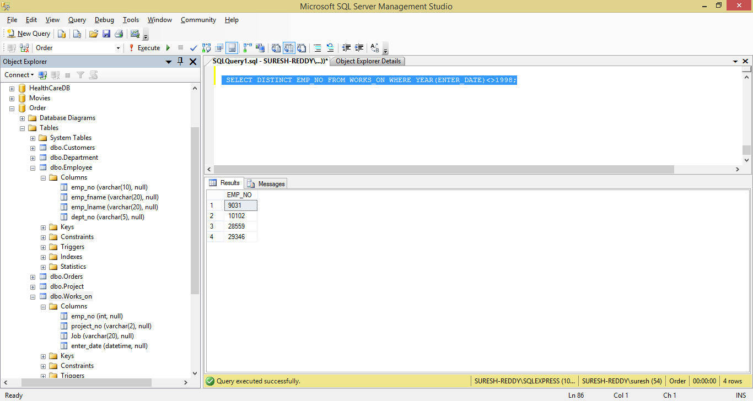

1. Get the employee numbers for all employees who have a leading job( i.e., Analyst or Manager) in project p14

SELECT DISTINCT EMP_NO

FROM WORKS_ON

WHERE project_no='P1' AND

(Job='Analyst' OR Job='Manager');

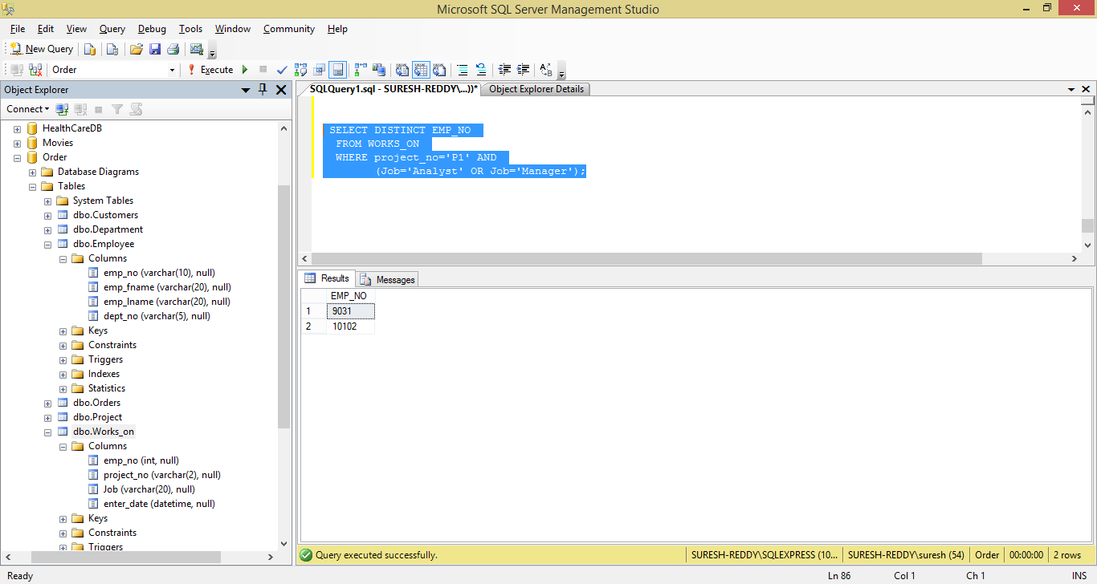

1. Get the enter dates for all employess in project p2 whose jobs have not been determined yet

SELECT DISTINCT Job,enter_date

FROM WORKS_ON WHERE project_no='P2' AND JOB IS NULL

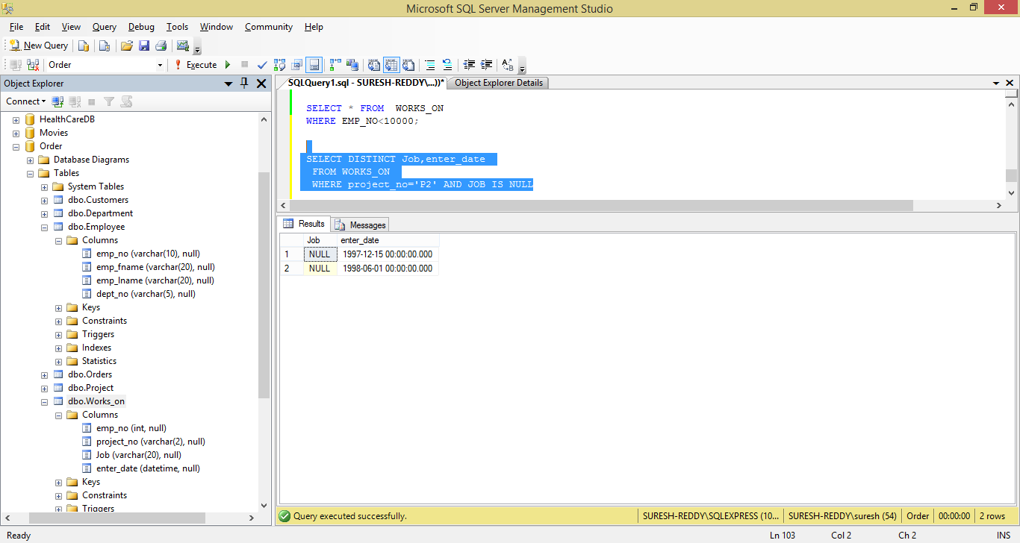

1. Get the employee numbers and last names of all employees whose first names contain two letter t’s

SELECT EMP_NO,EMP_LNAME FROM EMPLOYEE WHERE EMP_FNAME LIKE '%tt%'

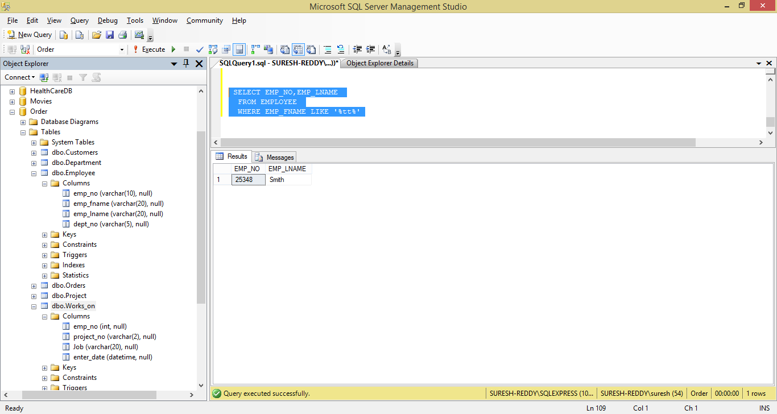

1. Get the employee numbers and first names of all employees whose last names have a letter o or a as the second character and end with the letters es

SELECT EMP_NO,EMP_FNAME FROM EMPLOYEE

WHERE EMP_LNAME LIKE '%o%' or

substring(LTrim(EMP_LNAME),2,1)='a' or EMP_LNAME LIKE '%es'

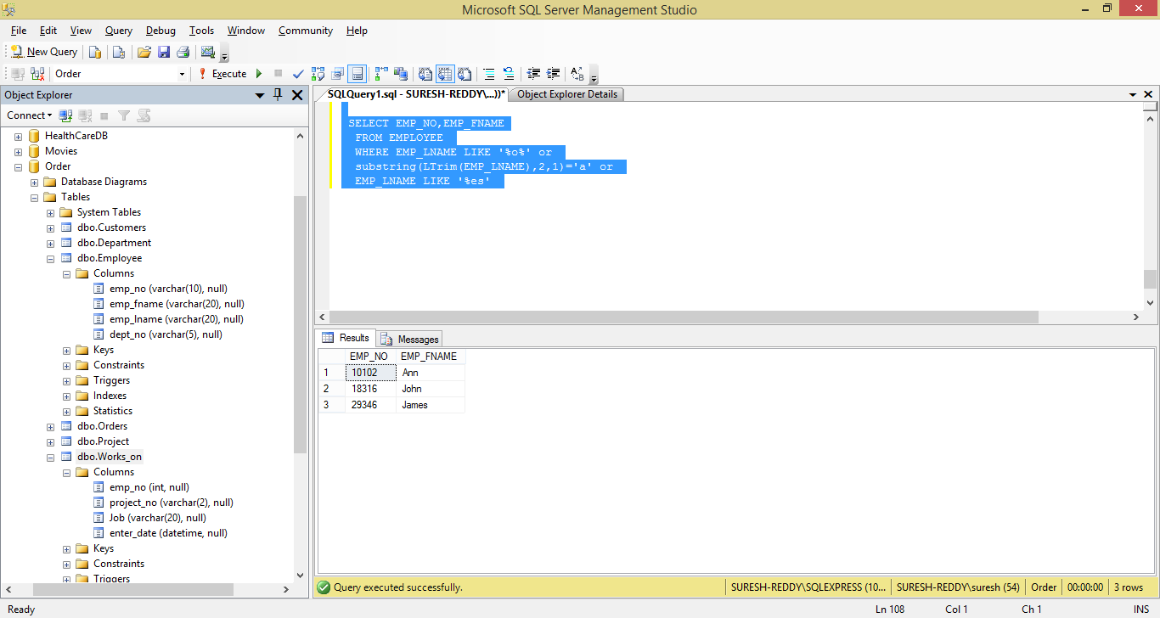

1. Get the employee numbers of all employees whose departments are located in Seattle

SELECT EMP_NO FROM

EMPLOYEE EMP INNER JOIN DEPARTMENT DEP

ON EMP.DEPT_NO=DEP.DEP

WHERE upper(location)=upper('Seattle');

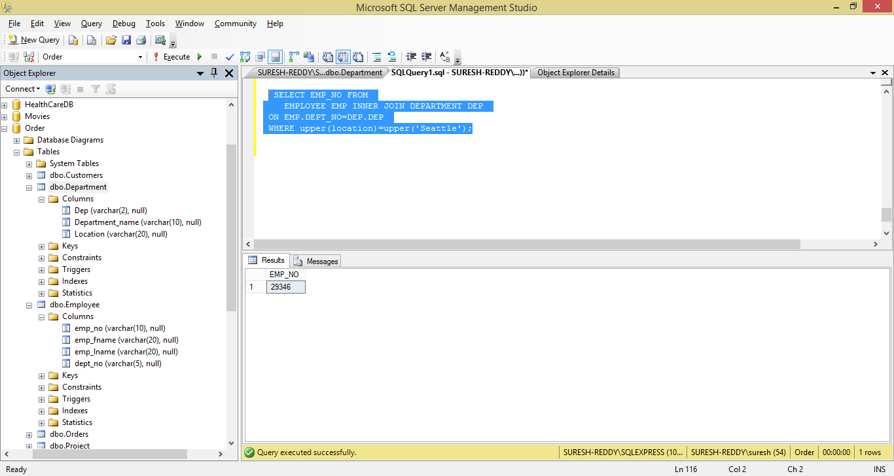

1. Find the last and first names of all employess who entered their projectson 04.01.1998

SELECT * FROM WORKS_ON

WHERE ENTER_DATE='1998-01-04'

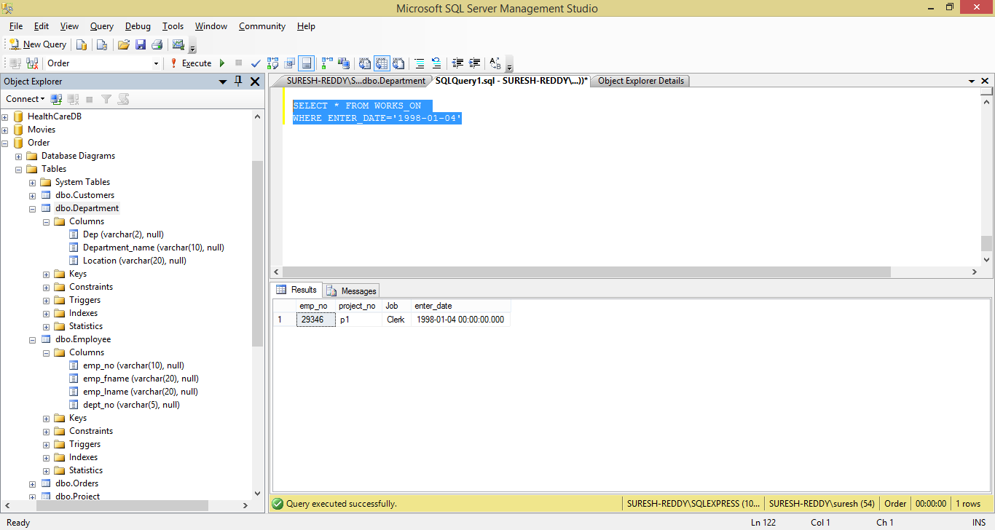

1. Group all departments using their locations

SELECT LOCATION, COUNT(*) FROM Department GROUP BY LOCATION

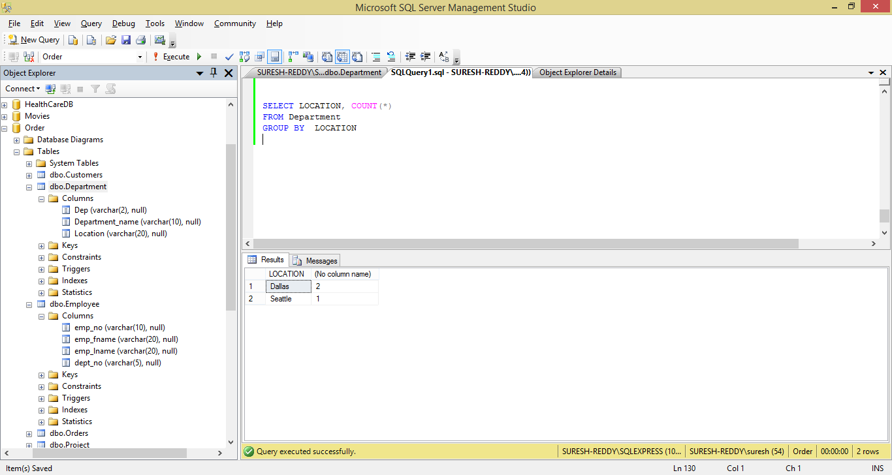

1. Find the biggest employee number

SELECT MAX(EMP_NO) 'Biggest_EmpNo'

FROM EMPLOYEE

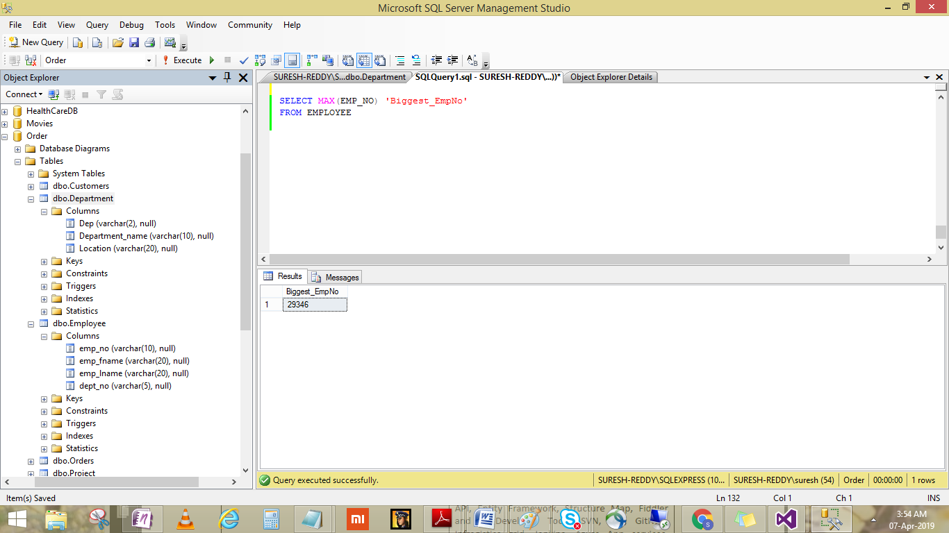

Views:

1. Create a view that comprises the data of all employees that work for the department d1

CREATE VIEW EmployeesInDepartment1

AS

SELECT * FROM EMPLOYEE WHERE dept_no='d1'

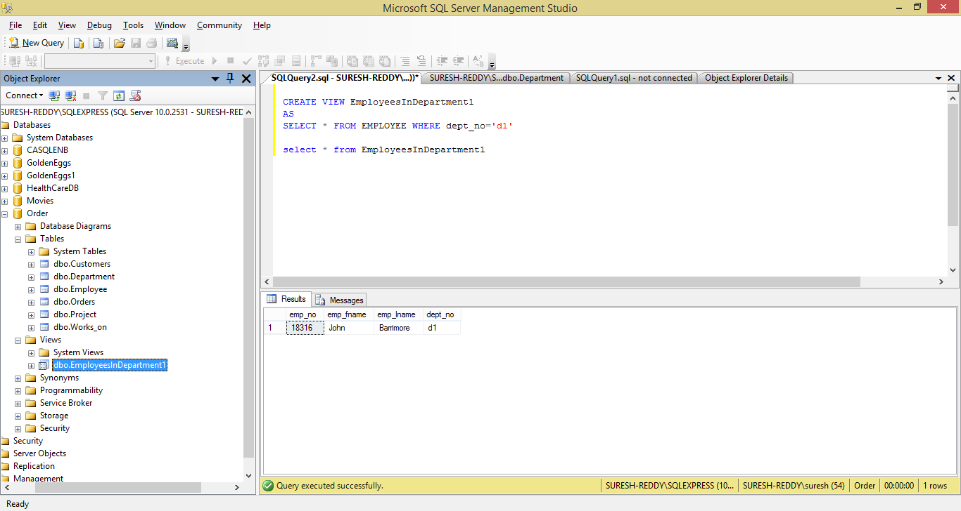

1. For the project table, create a view that can be used by employees who are allowed to view all data of this table except the budget column

CREATE VIEW vwProject AS

SELECT [project_no]

,[project_name]

FROM [Order].[dbo].[Project]

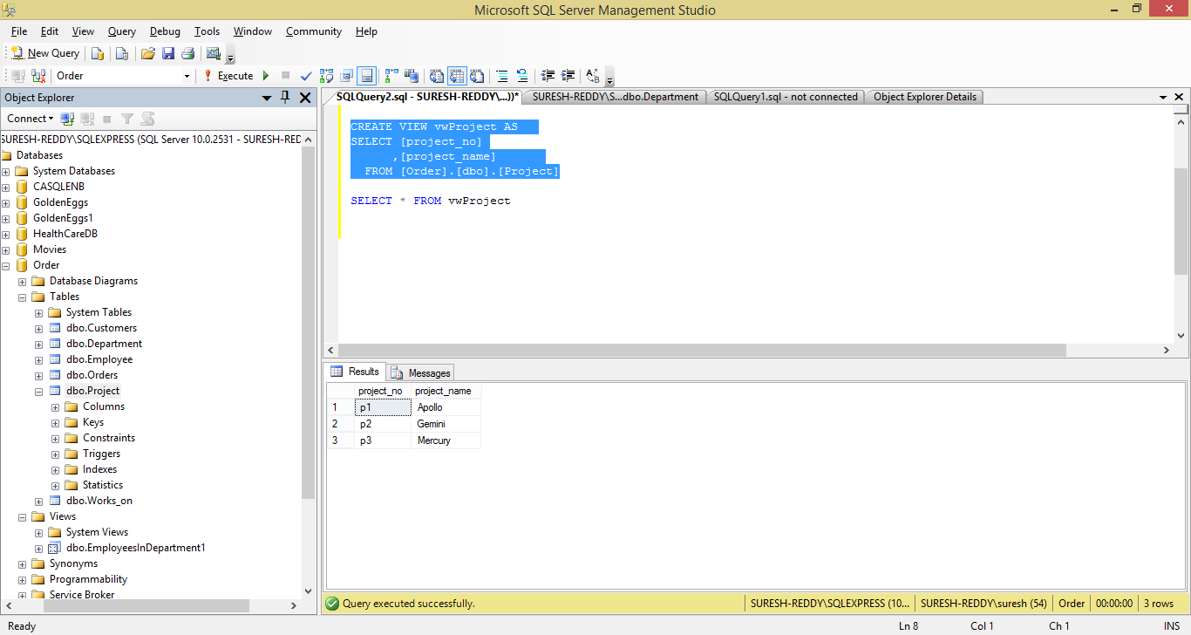

1. Create a view that comprises the first and last names of all employees who entered their projects in the second half of the year 1988

CREATE VIEW vmEmployeesEnterdInSecondHalf

AS

SELECT EMP_FNAME, EMP_LNAME

FROM EMPLOYEE EMP INNER JOIN WORKS_ON WORKS

ON EMP.EMP_NO=WORKS.EMP_NO AND

MONTH(ENTER_DATE)>6;

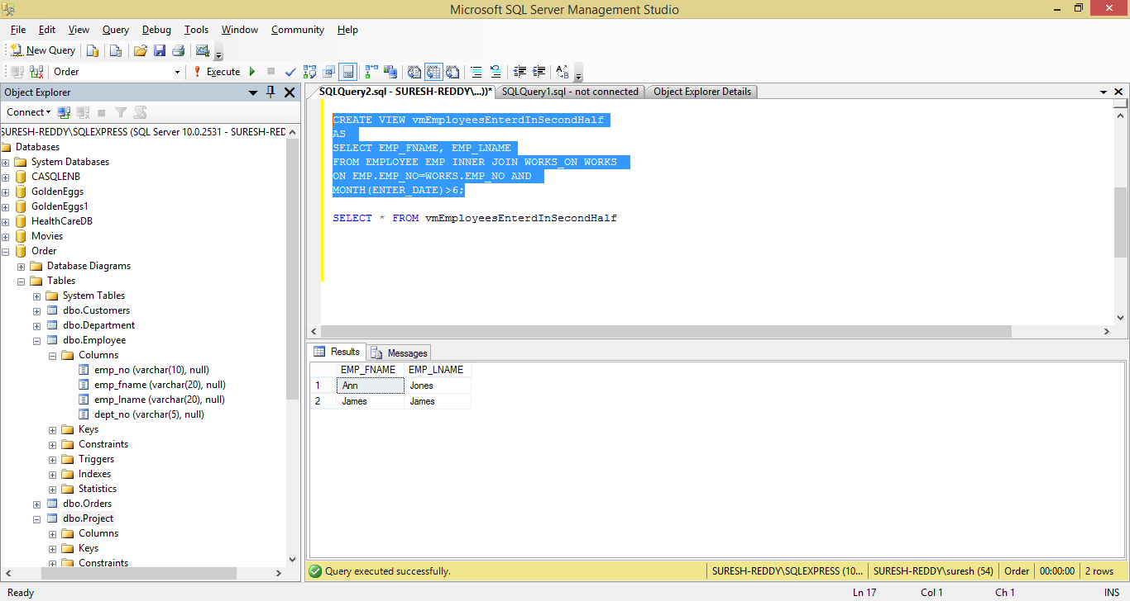

**Constraints**:-

1. Re-create the Customers and Orders tables, enhancing their definition with all primary and foreign keys constraints

--drop table Customers

CREATE TABLE Customers( id char(5) not null primary key,CompanyName varchar(40) not null,contactName char(30) null,

Address varchar(60) null,City char(15) null,Phone char(24) null,Fax char(24) null)

--drop table orders

CREATE TABLE ORDERS (ORDERID INTEGER NOT NULL PRIMARY KEY,

CUSTOMERID CHAR(5) NOT NULL FOREIGN KEY REFERENCES Customers(ID),

ORDERDATE DATETIME NULL, SHIPPEDDATE DATETIME NULL, FREIGHT MONEY NULL, SHIPNAME VARCHAR(40) NULL,

SHIPADDRES VARCHAR(60) NULL,QUANTITY INTEGER NULL);

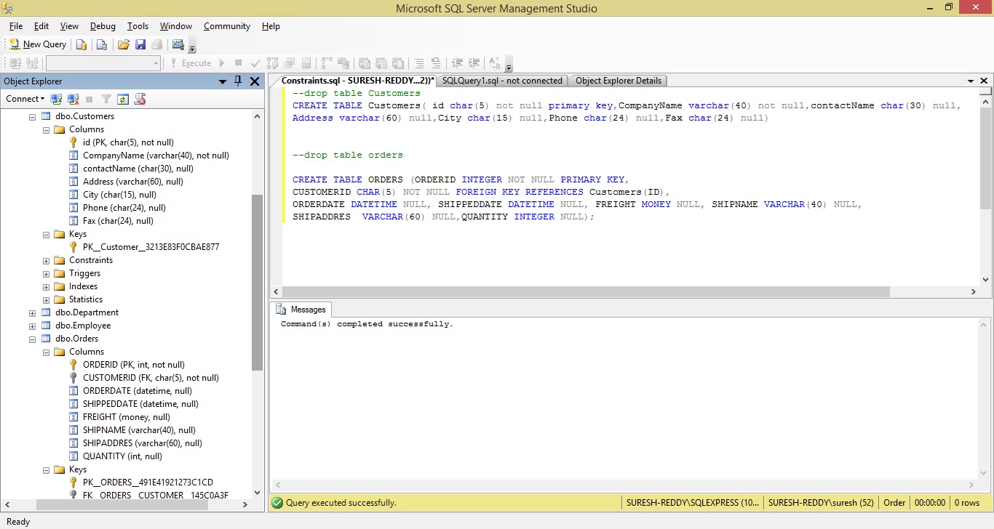

2. Using the ALTER TABLE statement, create an integrity constraint that limits the possible values of the quantity column in the Orders table to values between 1 and 30

ALTER TABLE ORDERS ADD CHECK (QUANTITY BETWEEN 1 AND 30);

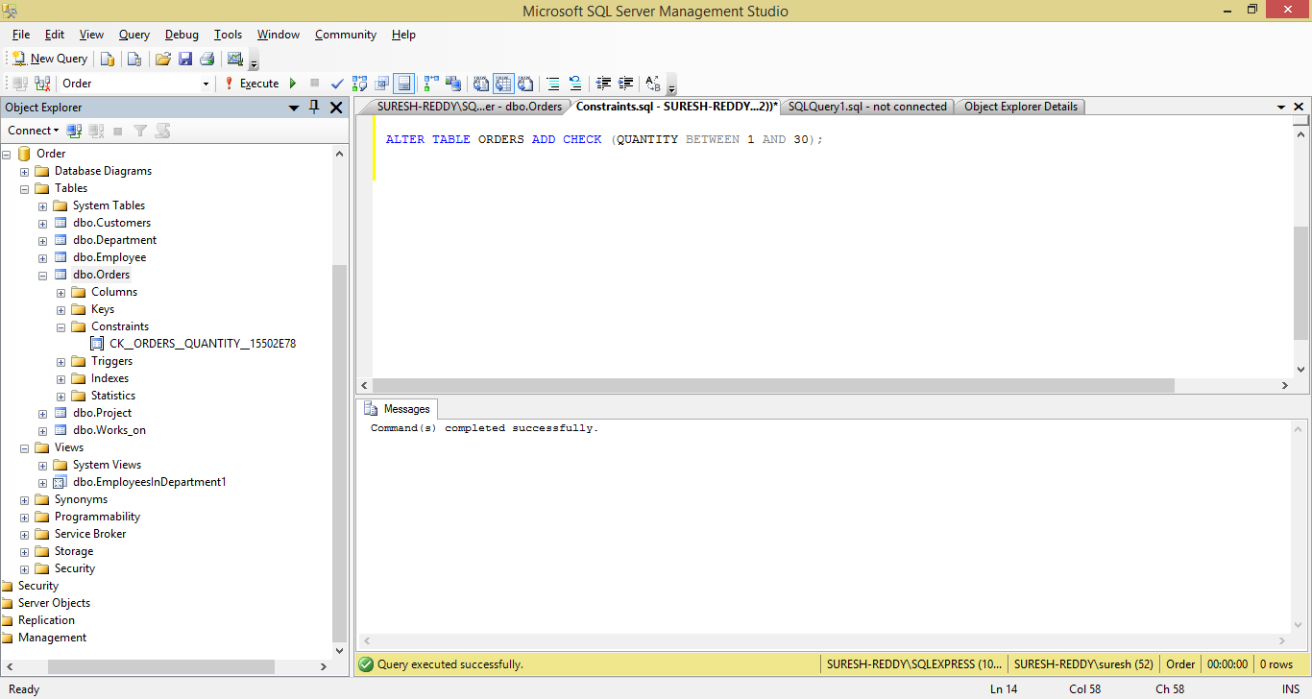

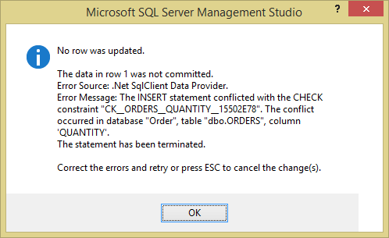

1. .With the help of the corresponding system procedures and the Transact-SQL statements CREATE DEFAULT and CREATE RULE, create the alias data type “Western Countries”. The possible values for the new data type are CA(for California), WA( for Washington), OR( for Oregon), and NM( for New Mexico). The default value is CA. Finally, create a table called Regions with the columns City and Country using the new data type for the later

CREATE DEFAULT Default_Country

AS 'CA'

GO;

CREATE RULE rule_Country

AS

(@country='Default_Country')

OR @country in ('CA','WA','OR','NM')

GO;

-- To bind a default 'Default_Country' to user defined data type 'Country'

EXEC sp_bindefault 'Default_Country', 'Country';

-- To bind a rule 'rule_Country' to user defined data type 'Country'

EXEC sp_bindrule 'rule_Country', 'Country';

CREATE TABLE Regions(City varchar(20), Country Country);

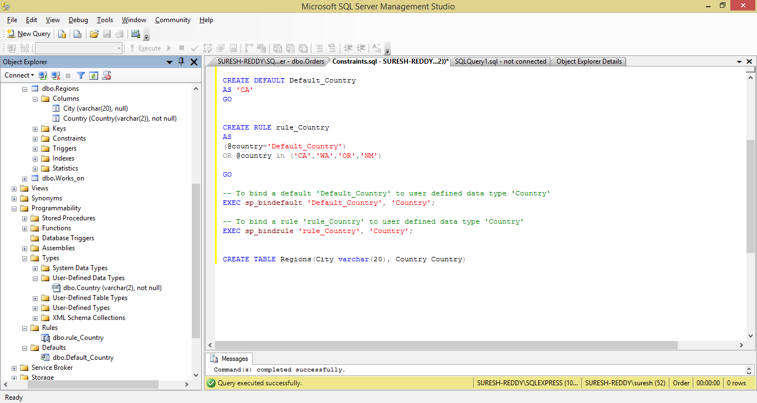

1. Display all integrity constraints for the Orders table

SELECT * FROM INFORMATION_SCHEMA.TABLE_CONSTRAINTS

WHERE TABLE_NAME='ORDERS'

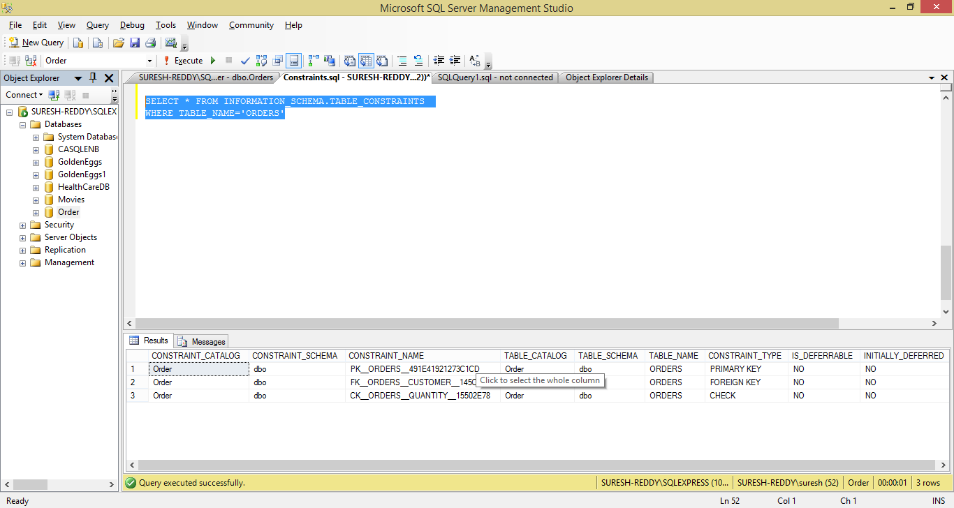

1. Delete the primary key of the Customers table

/*To see primary key constraint name*/

SELECT * FROM INFORMATION_SCHEMA.TABLE_CONSTRAINTS

WHERE TABLE_NAME='CUSTOMERS';

ALTER TABLE CUSTOMERS DROP CONSTRAINT PK__Customer__3213E83F0CBAE877

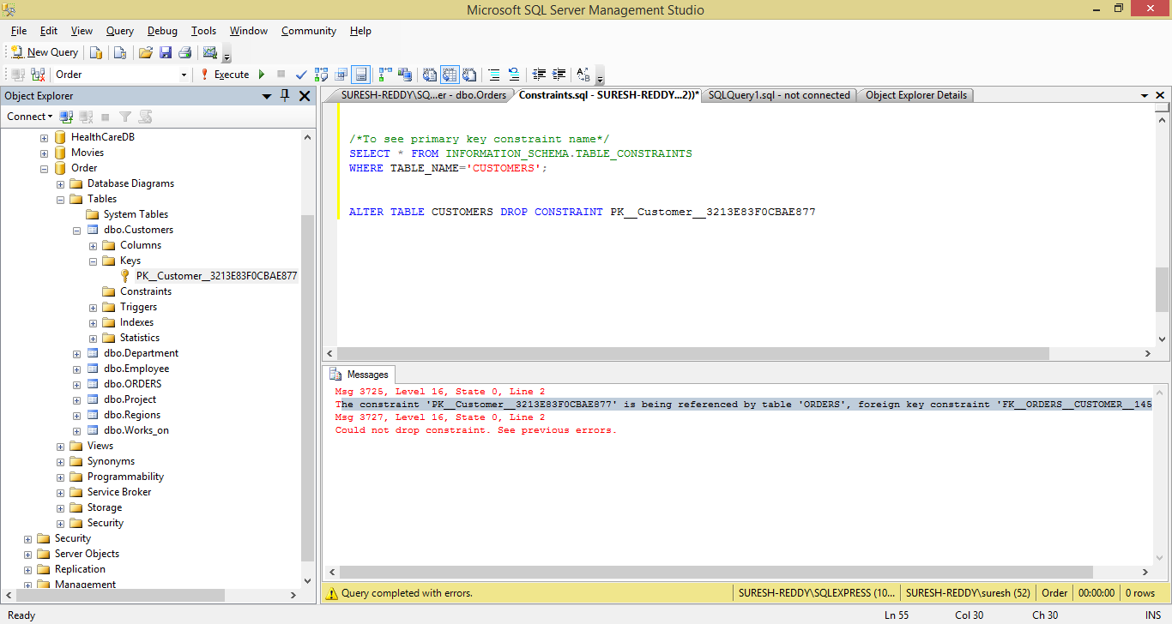

1. Delete the integrity constraint defined in Step-2

ALTER TABLE Orders DROP CONSTRAINT CK__ORDERS__QUANTITY__15502E78;

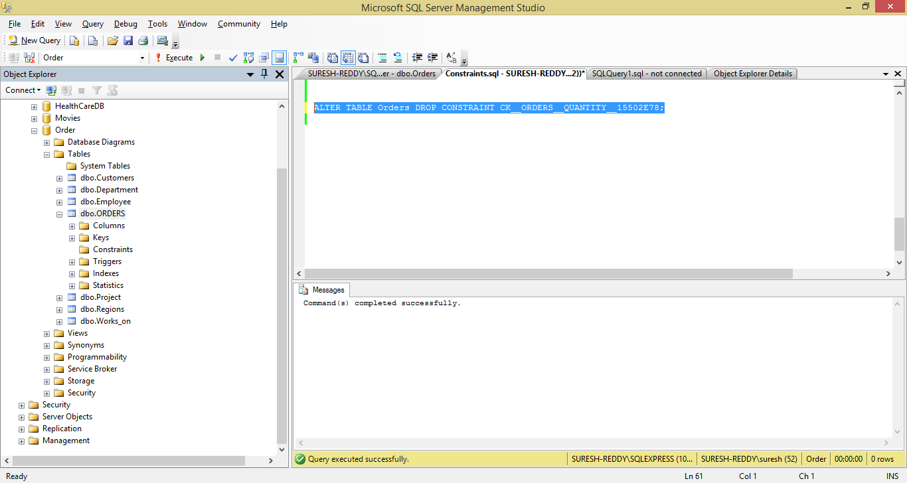

**Functions and Procedures:**

1. Write a function that will return the age of the person given his or her date of birth

CREATE FUNCTION FNC_CALCULATEAGE(@DATE_OF_BIRTH DATETIME)

RETURNS INT

AS

BEGIN

DECLARE @AGE INT

SELECT @AGE=FLOOR((CAST (GETDATE() AS INTEGER) - CAST(@DATE_OF_BIRTH AS INTEGER)) / 365.25)

RETURN @AGE

END;

select dbo.FNC_CALCULATEAGE('04.07.2000');

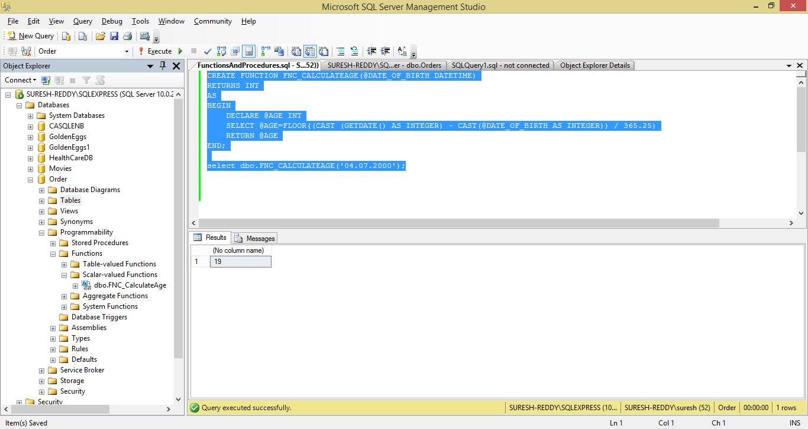

2. Write a procedure that accepts name and data of birth of the student and inserts the data in the student table with the date computed. The SID should be largest sid in the table +1

CREATE TABLE STUDENT(SID INTEGER PRIMARY KEY, NAME VARCHAR(50), DATE_OF_BIRTH DATETIME, AGE INT);

/*Creating store procedure*/

CREATE PROCEDURE SP_STUDENT_INSERT

(@NAME VARCHAR(50),

@DATE_OF_BIRTH DATETIME

)

AS

BEGIN

DECLARE @AGE INTEGER

DECLARE @STUDENT_ID INTEGER=0

SELECT @STUDENT_ID=isnull(MAX(SID),0)+1 FROM STUDENT

SELECT @AGE=dbo.FNC_CALCULATEAGE(@DATE_OF_BIRTH);

INSERT INTO STUDENT(SID, NAME, DATE_OF_BIRTH, AGE)

VALUES(@STUDENT_ID,@NAME,@DATE_OF_BIRTH,@AGE)

END

/*Insert Rows*/

EXEC SP_STUDENT_INSERT 'Surekha','12.12.2001'

SELECT * FROM STUDENT;

